UMBC Search Match Job Aid

INITIAL SETUP FOR DEFAULT SETTINGS

- Navigate to one of the following (based on your Security access):
- Workforce Administration / Personal Information / Search For People
- Campus Community / Personal Information / Search Match

- On the Find an Existing Value page:
- Select the Search Type of PERSON (or press the letter P on your keyboard)
- Select the Search Parameter = UM_HR_BASIC
- Click on the Save Search Criteria (prior to accessing the Search Match page) and name the search BASIC. This will allow you to quickly access frequently used Search Parameters.
- After it has been saved, click on the Return To Advanced Search link
- Select the Use Saved Search = BASIC

- Once on the Search Criteria page, click on the User Default link:
  - Select the UM_HR_RESULTS from the drop down Search Result Code list
  - Click on the OK button
  - Enter the desired data in the fields – IMPORTANT be sure to TAB out of each field to be able un-gray the Search button
  - Click on the Search button

- When the Search Results page is displayed, click on the expand button

- Click on the Carry ID button next to the Person you want to view more information on. This allows the ID to automatically be used when accessing another component (or page).

- Click on the Person Organizational Summary link to view more detailed information. The system will open a new window. (It takes a few seconds for it to appear.)

- If this is the Person you were “looking” for, write down the ID. If it isn’t, close down the Person Org Summary page by clicking on the on the upper right hand corner, and review the list on Persons to see if another Person matches the data you have.

Quick Search Match using Basic

- Navigate to the Search Match component - Find an Existing Value page. Click on the Used Saved Search drop down list box and select BASIC.
- The Search Criteria page will display. Enter your data in the appropriate field boxes and click on the Search button

Sample Search Match Page Shots

There are two ways to access the page. By drilling down on the menu bar on the left and clicking on the menu item or by clicking on the Search for People icon on the right.

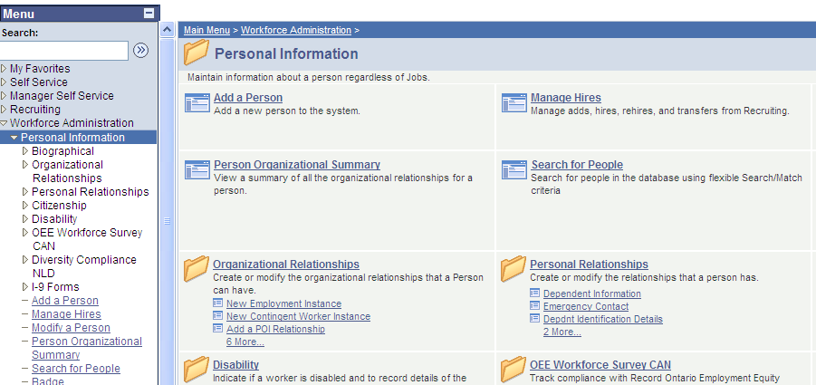

Once you have set up your default settings, per the previous pages’ instructions, you will not have to re-enter certain data. From the Use Saved Search field simply select BASIC and you will be taken to the Search Criteria page.

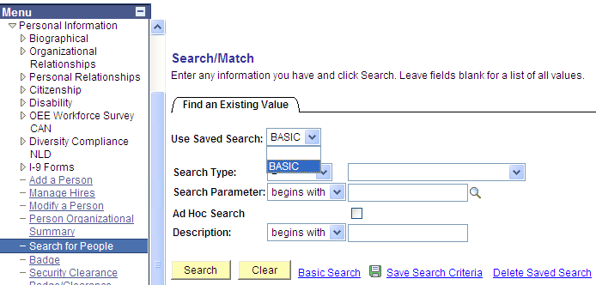

The Search Criteria page will display.

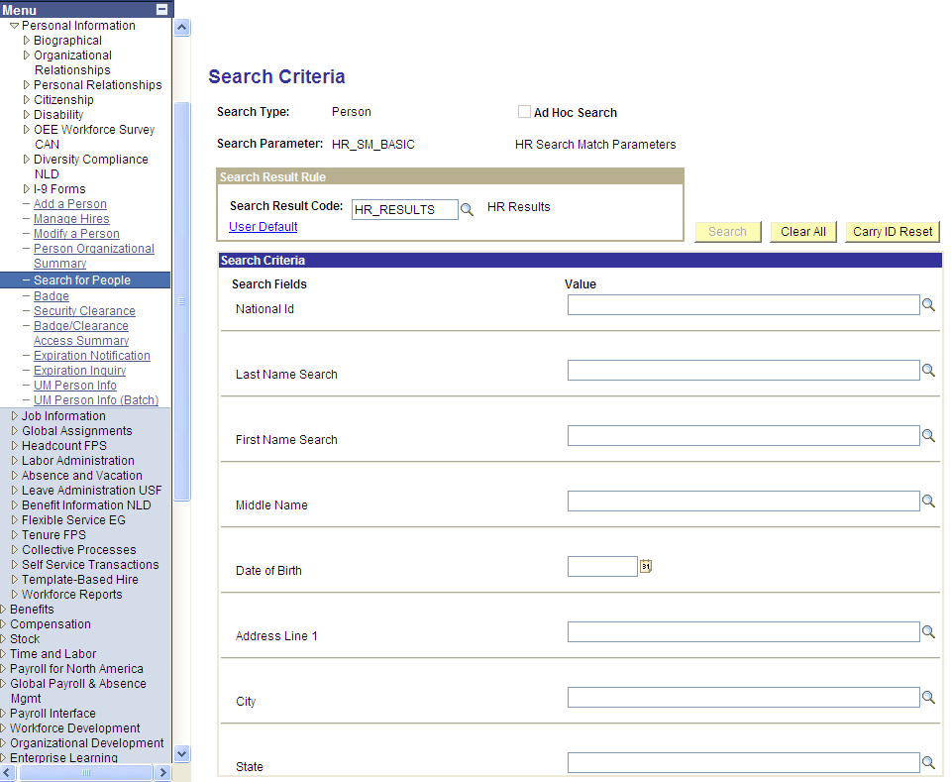

The fields available to search on depend on the Search Parameter you select. Each one is designed differently.

There is an additional Search Parameter option. It is HR_ADHOC. See pg. 11 for more information.

Enter the information you have (remembering to tab out of each field).

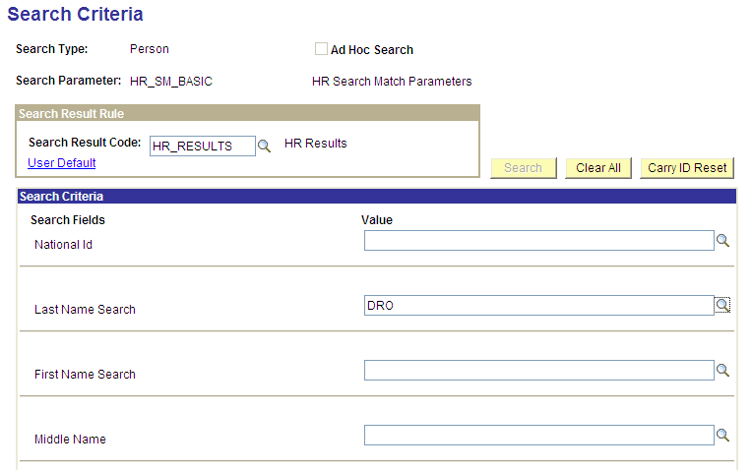

The Search button becomes available after entering the minimum required fields. Click on it for your results.

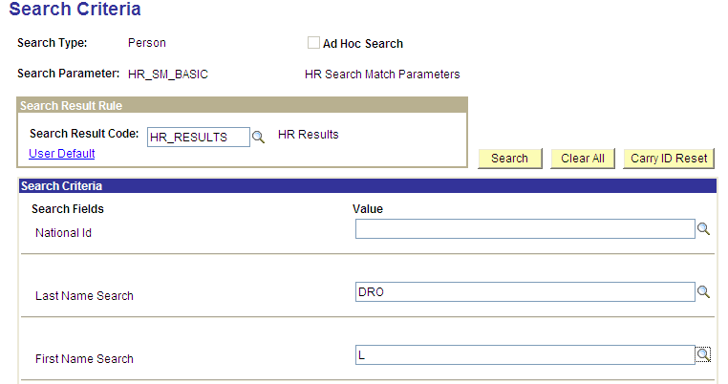

In this example, 3 people were retrieved from the Search:
- 2 employees
- 1 POI (non-employee) who was a type = 0009 (Campus Solution)

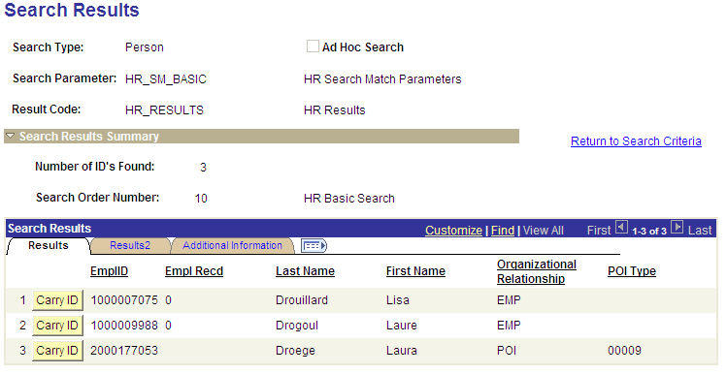

The Number of ID’s Found indicates how many unique ID’s were found.

For example, if a person has an Employment and a POI record, they will show up twice increasing the result lines to 5 but keeping the number of ID’s to 4. See below example.

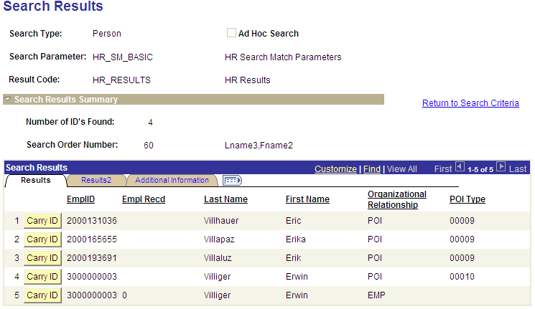

If you click on the expand view button you will see a Results View that was designed to bring additional information about the person.

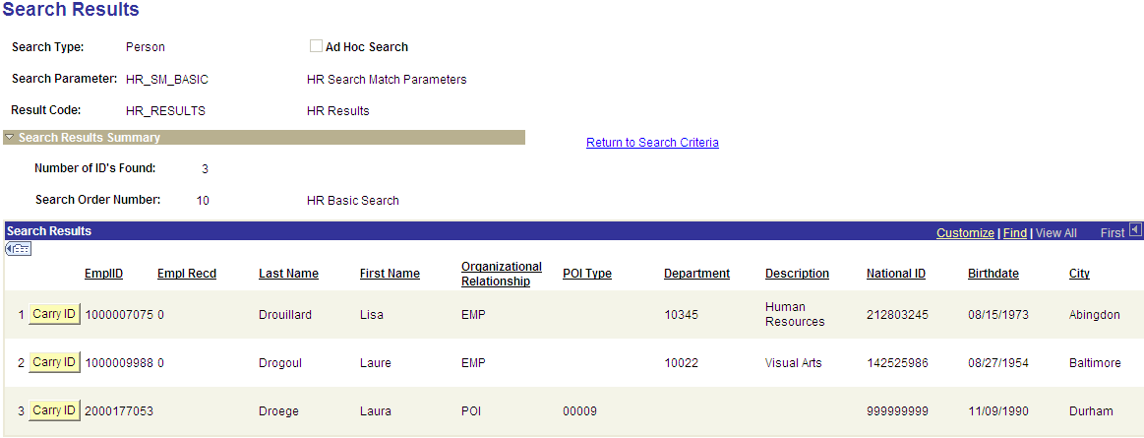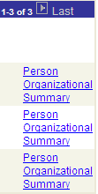

Please Note: The National ID will display differently depending on your Security access. Employees of the Human Resources department will view the entire value, while others will see a partially masked SSN – revealing only the last 4 digits.

Person Organizational Summary

Three categories of people will be in the database:
- Employees (active and terminated) with or without multiple jobs
- Contingent Workers (former Auditors who were on campus – just a hand full)
- Persons of Interest (as Student Administration goes live at UMBC more types will exist):
  - Student prospects – potential student recruits
  - Applicants
  - Students
  - Advisors
  - Instructors paid by Accts Payable, not thru Payroll
  - HR/Other – for people who are not employees but have an affiliation with UMBC

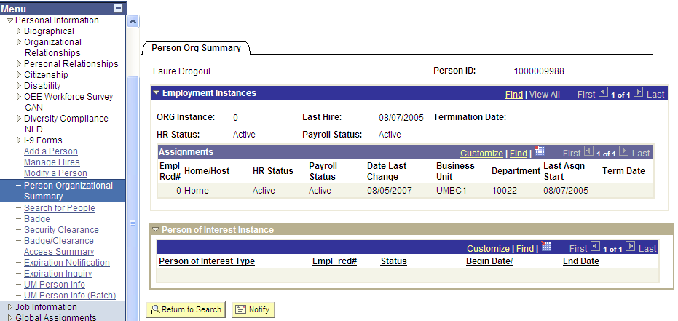

Sample of what a Student prospect (without a Job) will look like:

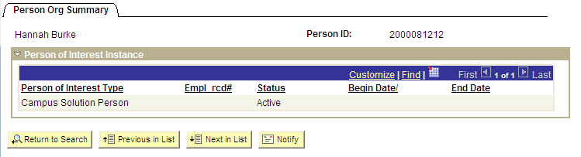

Sample of a terminated employee:

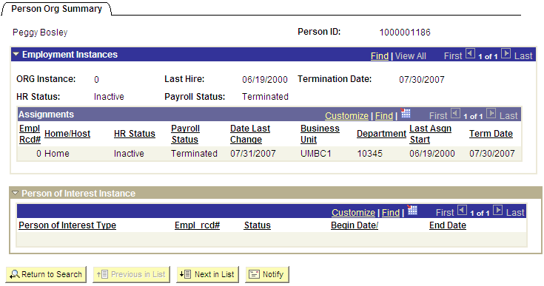

Sample of a person with multiple jobs:

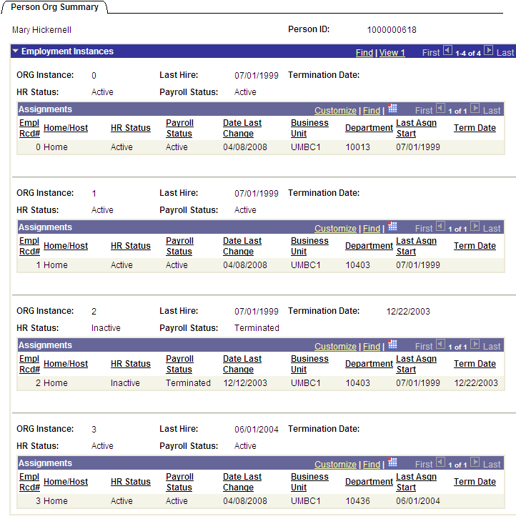

Sample of a Contingent Worker:

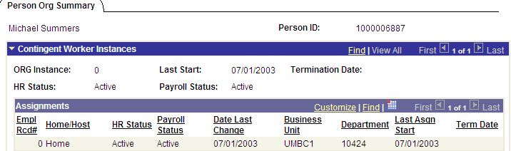

Shut down the page by clicking on the red x in the corner of your screen . This will return you to the Search Results page.

If you want to view another Person, click on the Carry ID button next to the EmplID and then click on the Pers Organizational Summary link to the far right.

If you want to modify or conduct another Search, click on the Return to Search Criteria link.

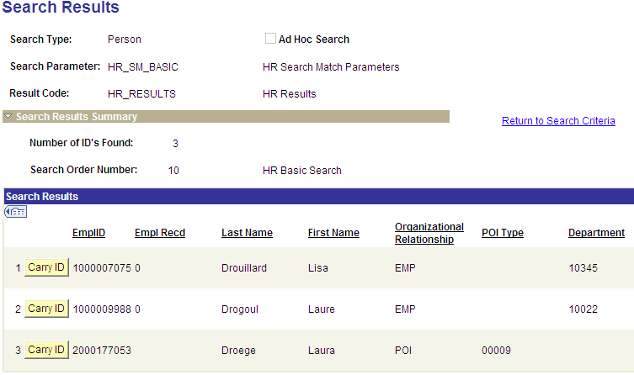

Search Order Number indicates which combination of criteria was used to find matches.

In this example, since we only entered 3 letters in the last name (DRO) and 1 letter in the first (L), it found matches using this limited data.

Important Note: The more information provided in the Search fields, the narrower the results will be.

The Description of each Search Order gives you a hint on how you can narrow down your Search Results. The number behind each field indicates how many letters will be used in that criteria set.

- Lname = Last Name
- Fname = First Name
- National ID (SSN) = Social Security Number
- DOB = Date of Birth
- City = City
- Address = Street address
- Gender = Female or Male

For example, “Lname3” means the Search will look at the first 3 letter of the last name. So SMI would retrieve names including Smithsonian, Smith, Smite, Smipson, etc.

If “Lname5” were used and you entered SMITH, it would exclude numerous names.

The combinations tell you what you could enter to get the most precise search. So if you know the SSN, enter it, and then press the Selective Search button to retrieve an exact match if it exists.

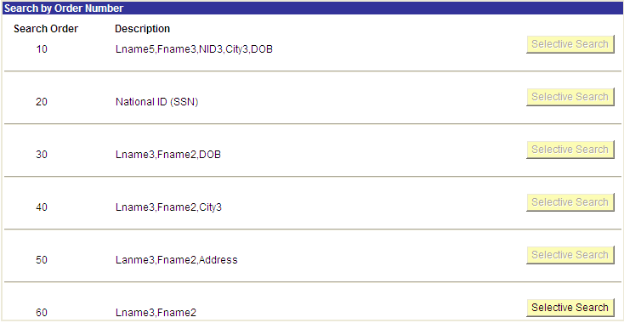

Ad Hoc Searches

Ad Hoc searches allow users to define their own criteria for a search using pre-designated fields.

First, click on the Ad Hoc Search check box.

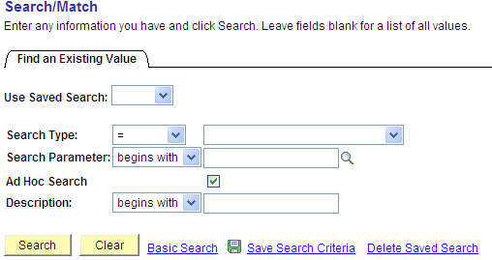

Click on the Search button to bring the list of Ad Hoc searches available.

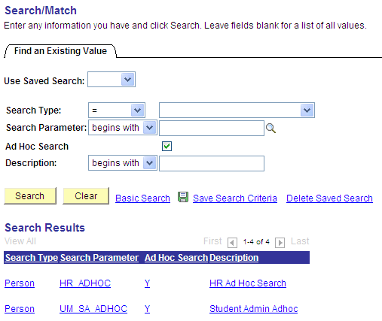

Click on the desired one.
In this example, select HR_ADHOC.

Notice the following:

- The Ad Hoc Search box is checked on
- There are nine fields you can use. You may enter data in one, many or all of them.
- The Operand drop down list box allows you the option to select your criteria.

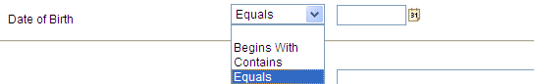

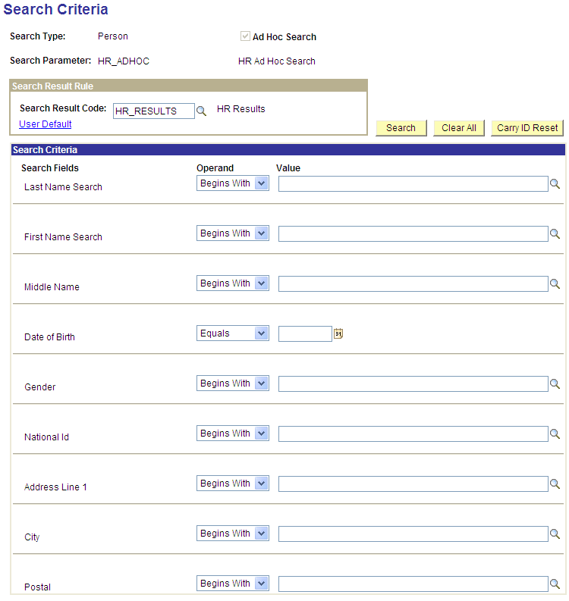

In this example, the Last Name equals a value, the First Name begins with a value and the Gender is equal to a value.

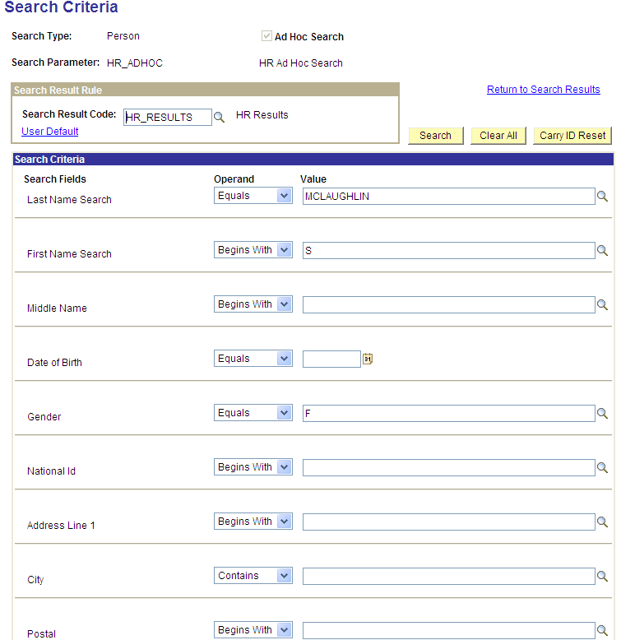

Click on the Search button to obtain your results.

You can also click on the Clear All Button if you want to select different fields and enter different values.

The system retrieved 4 ID’s. Click on the Return to Search Criteria to modify your selection.

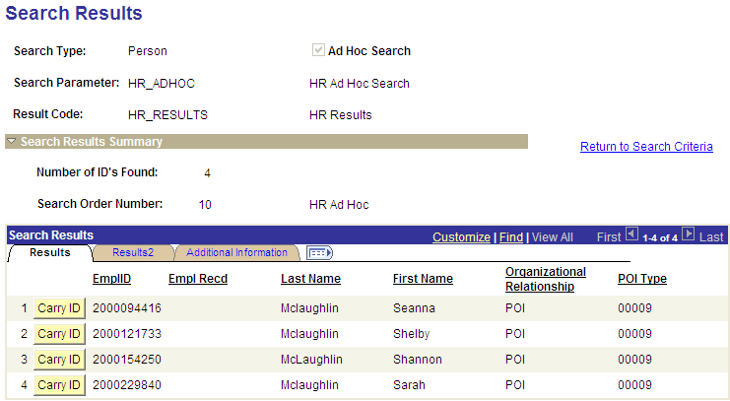

You can also change the Results view by clicking on the User Default link on the page.

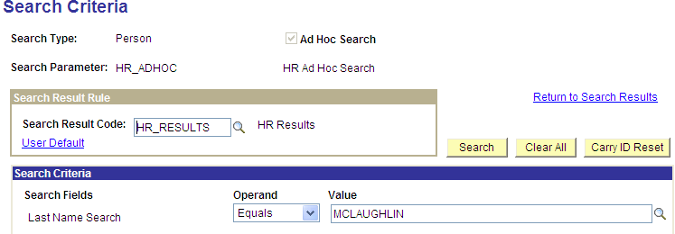

By clicking on the magnifying glass , you will see other Results views available to you based on your Security.

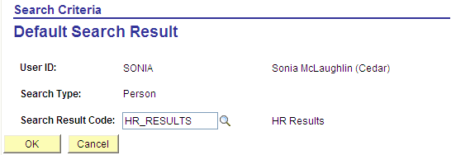

Click on the UM_SA_BASIC_RSL link.

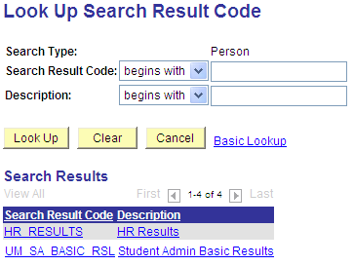

Click on the OK button.

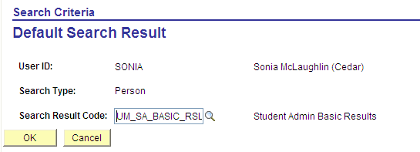

When you click on the Search button (without having altered your criteria)

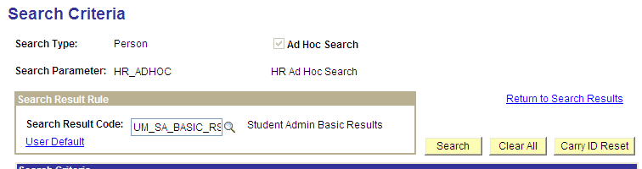

In this example, you get the same results (4 ID’s Found) but a different set of data associated with the 4 records (gender, email, and address information).

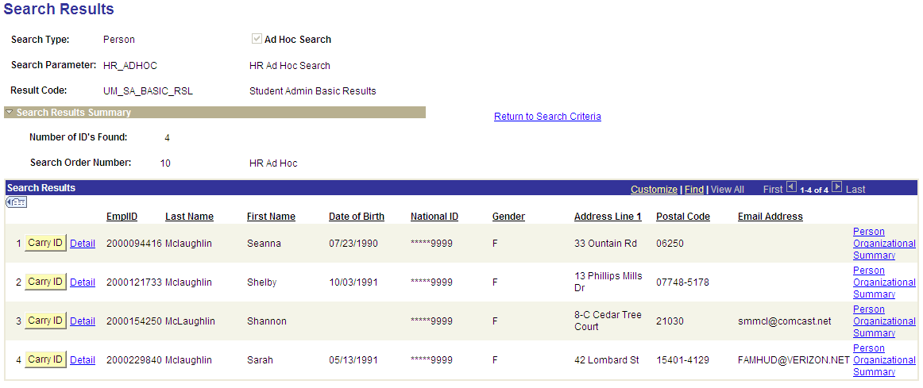

There will be times when the Search Results will be different if you UM_SA_BASIC_RSL. This is due to the system, as designed, to retrieving multiple rows if a person has multiple name types, address types, or phone types. Let’s look at an example on the next page.

We entered the name Samuel Lee and obtained 7 individuals using the HR_RESULTS view.

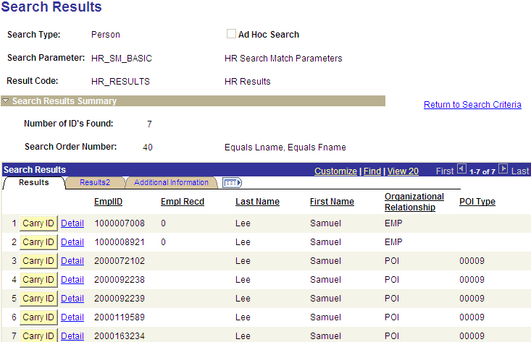

When we used the UM_SA_BASIC_RSL view we saw the same 7 records but 1000008921 had 2 rows. You can view his Bio Demo data by clicking on the Detail link.

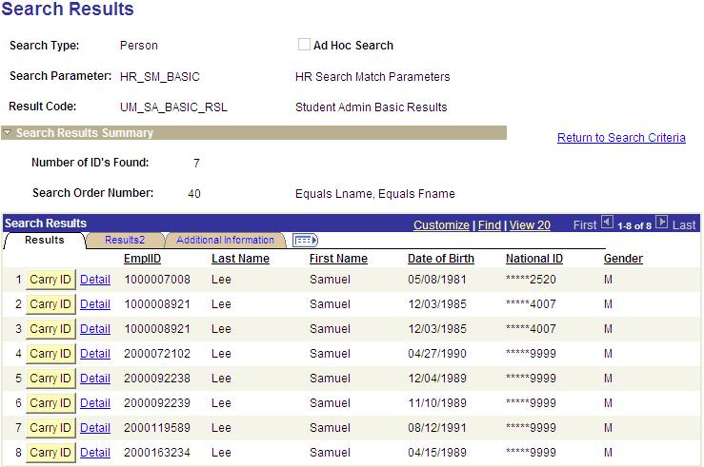

This is an example of how his addresses would appear in the system using the Campus Community view of Personal Data.

You will notice that he has two address types: HOME and CHECK.

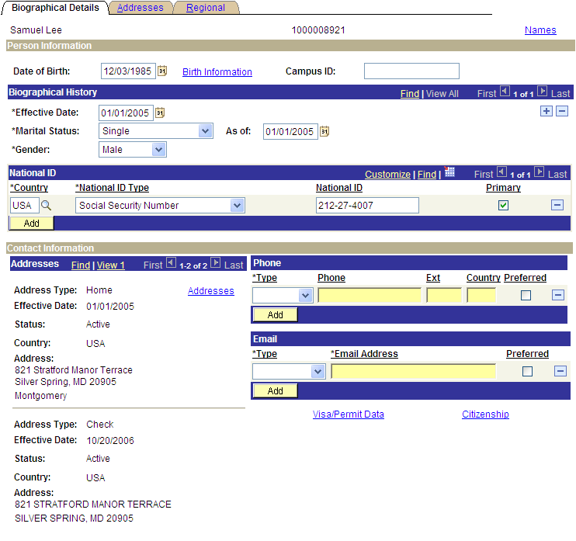

On the next page is a sample of doing a Search just using National ID.

Example of a Search using National ID:


